IT3037c
Lab#0.5: Amazon VPC Set-up

In this lab, you set-up your AWS VPC for later labs. You will use the AWS console to set this up.

Tools and Materials
- Ubuntu VM with AWS Credentials for the Command Line.
- AWS Console

Note: You need to replace words in italics with your information. Be sure to show your output.
Questions will be in red.
Part 1: Create your VPC
BEFORE YOU PROCEED MAKE SURE TO CLICK THE REGION TO us-east-1 for North Virginia LIKE SO OR YOUR LABS WILL NOT WORK!
1. Make sure you’re in the correct region for the course which is us-east-1
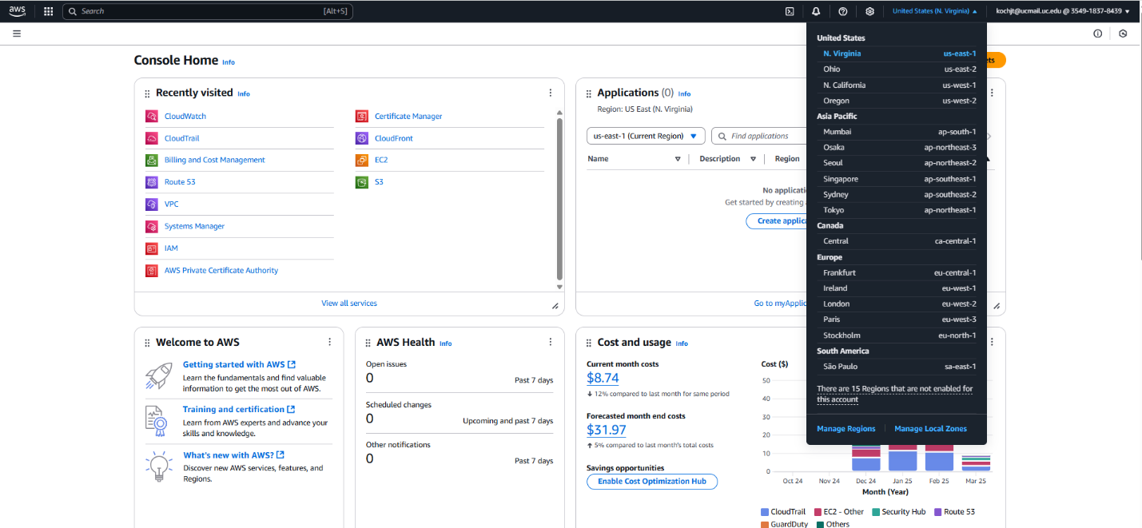
What region are you in please provide a screenshot?
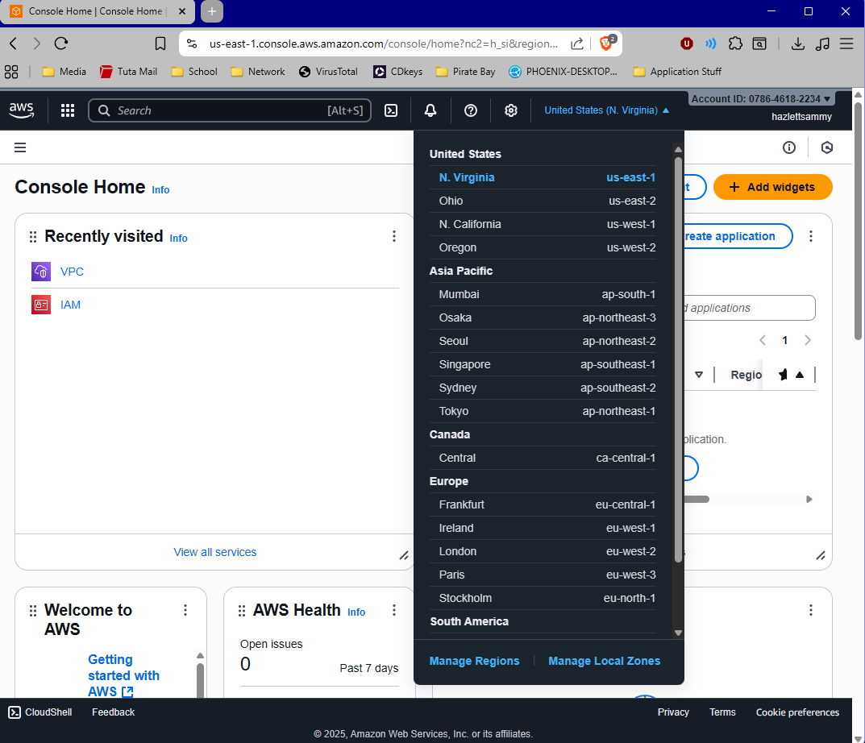

2. Sign into the AWS Console and navigate to the VPC service like so:

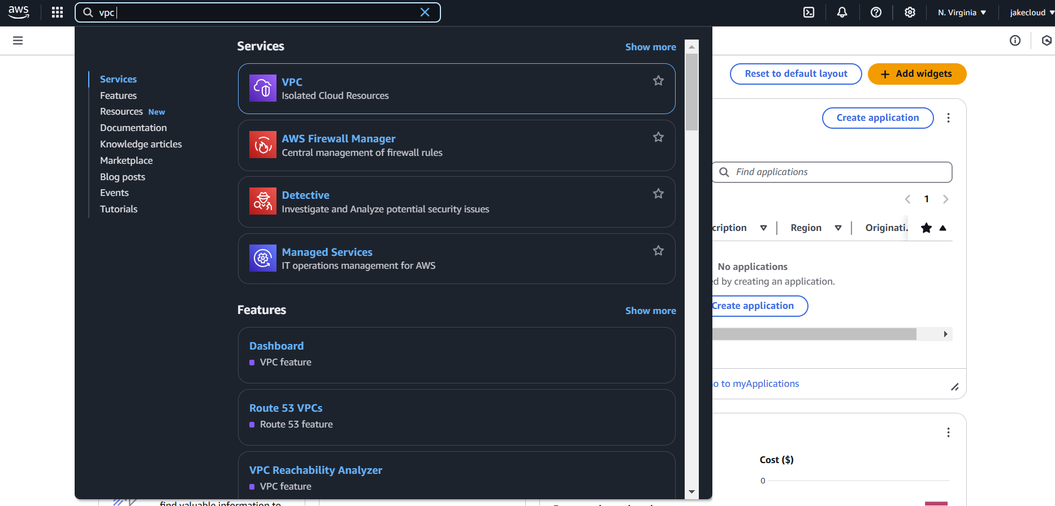

2. Click “Create VPC”
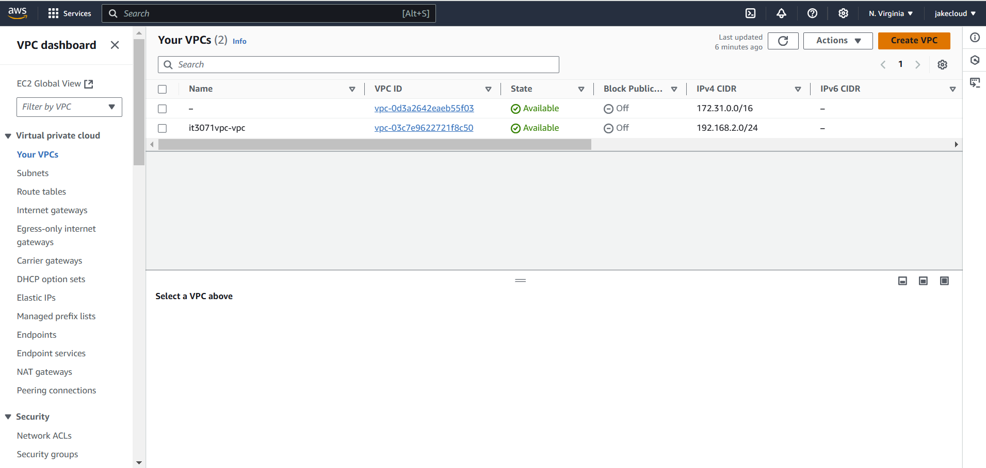
3. Then Click “VPC and more” as shown below.
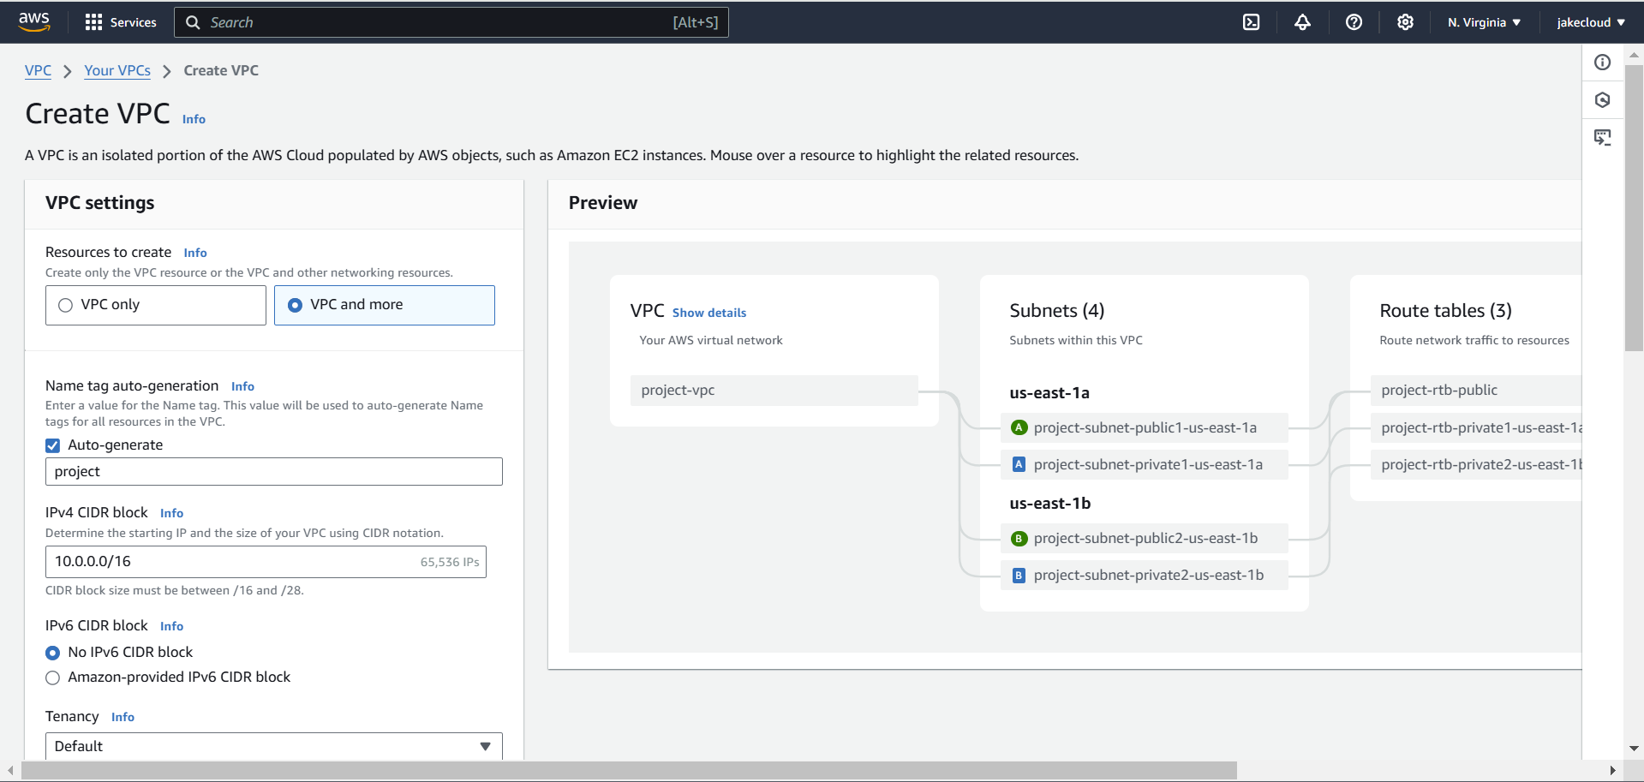

4. Configure your VPC as follows:
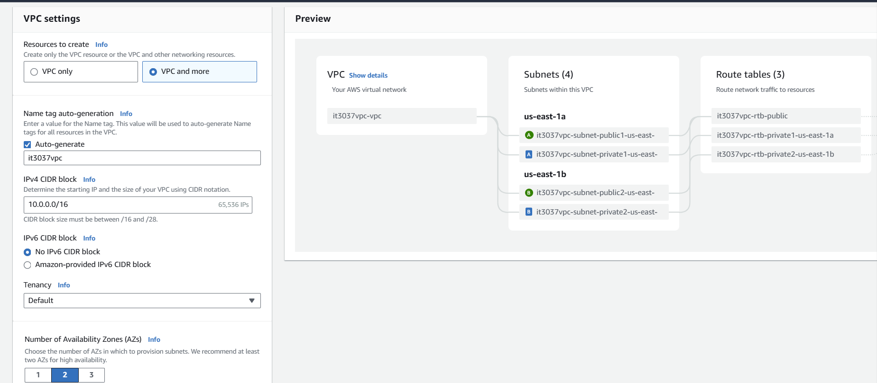
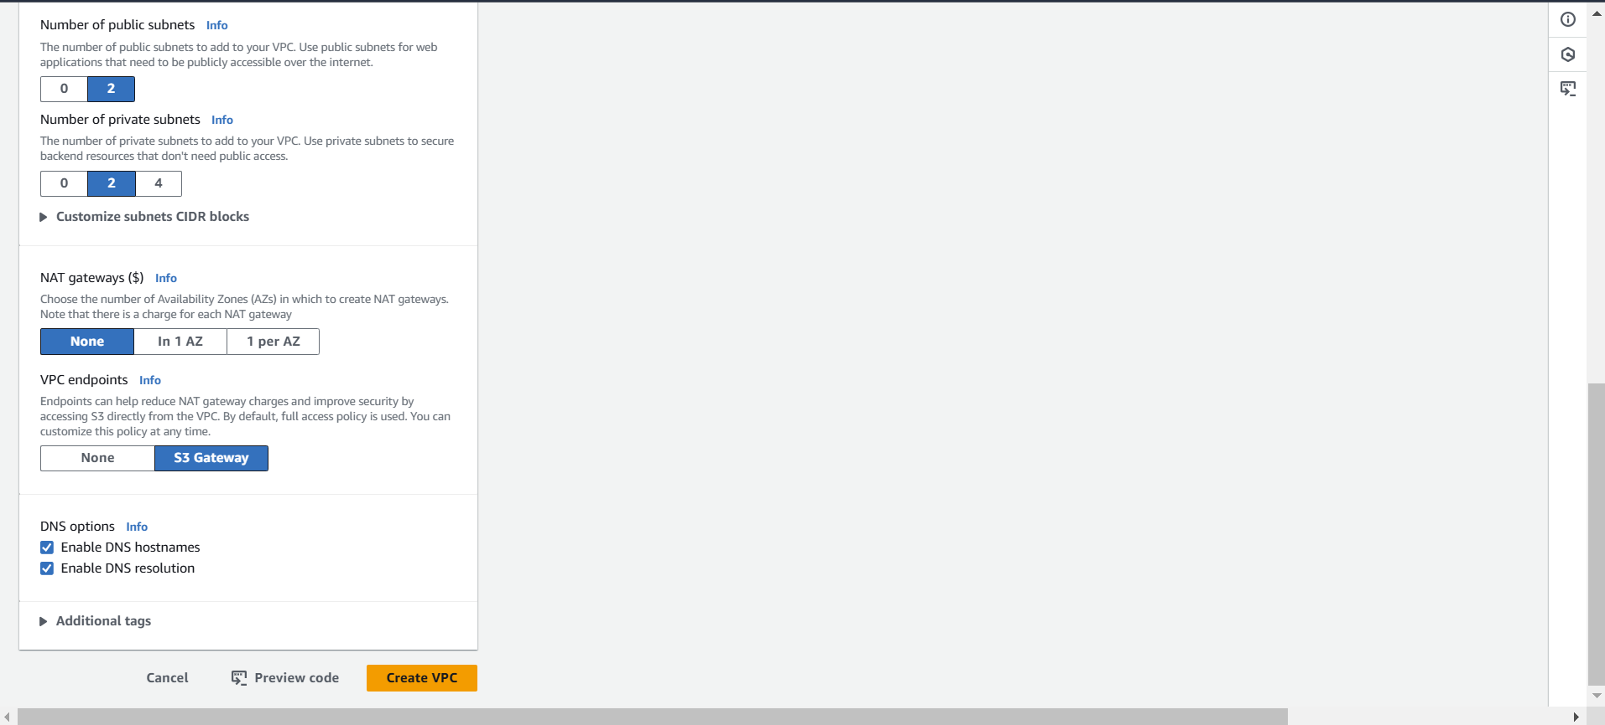
What is your configuration? Take a screenshot of your entire configuration.
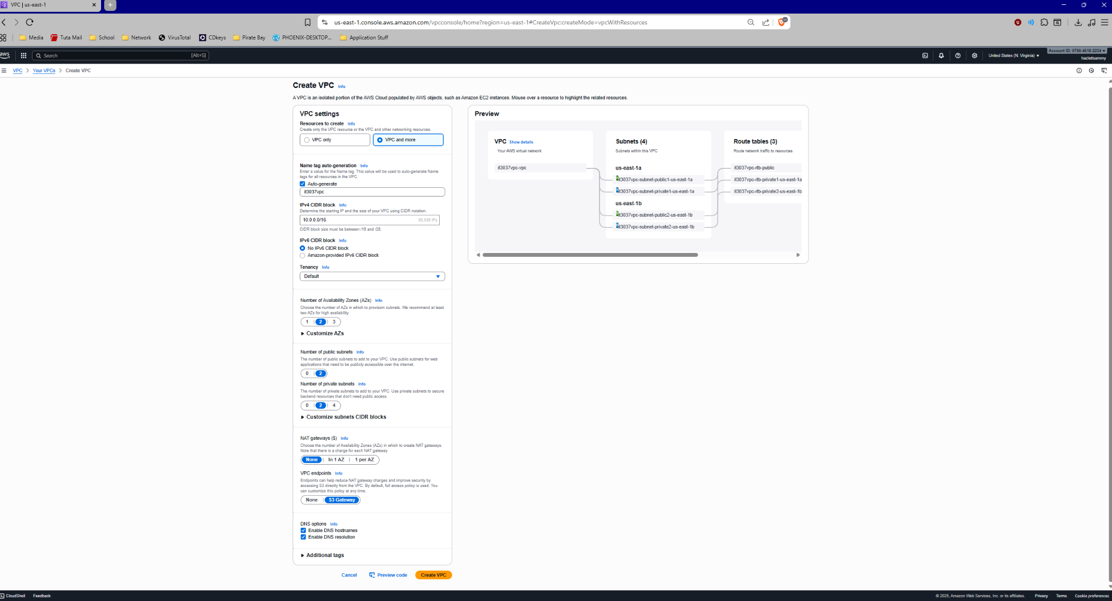
5. After you have configured your VPC, you can click “ Create VPC” . This should bring you to a screen similar to this DO NOT CLICK OUT OF THIS YET:
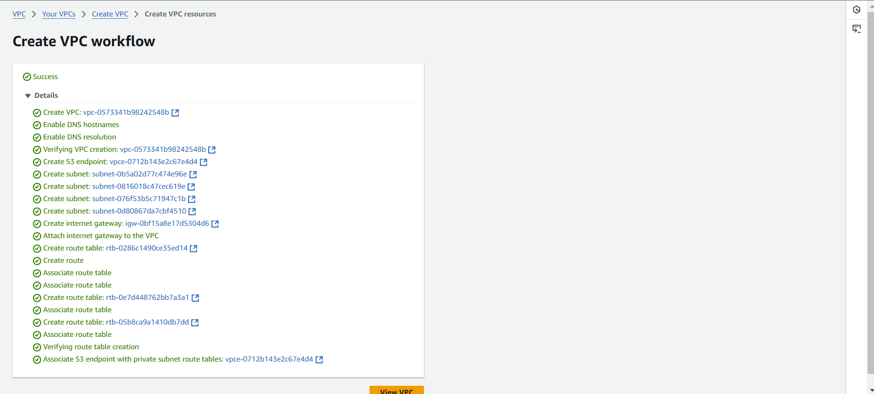
What is your VPC ID?
vpc-0202cda9d76509845
6. Click your first subnet, which should be your public1-us-east-1a subnet
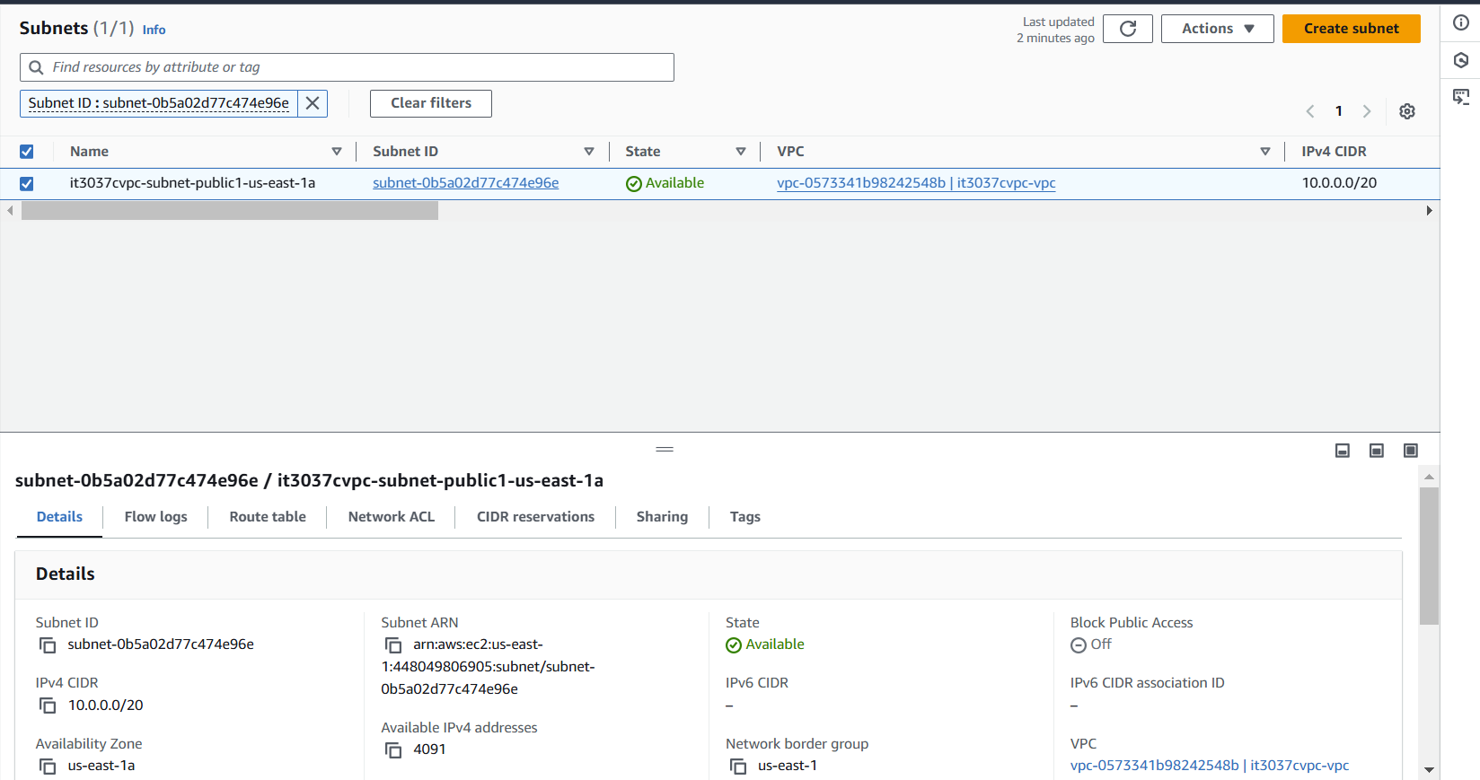

7. Click the subnet id and it will bring you to the following menu:
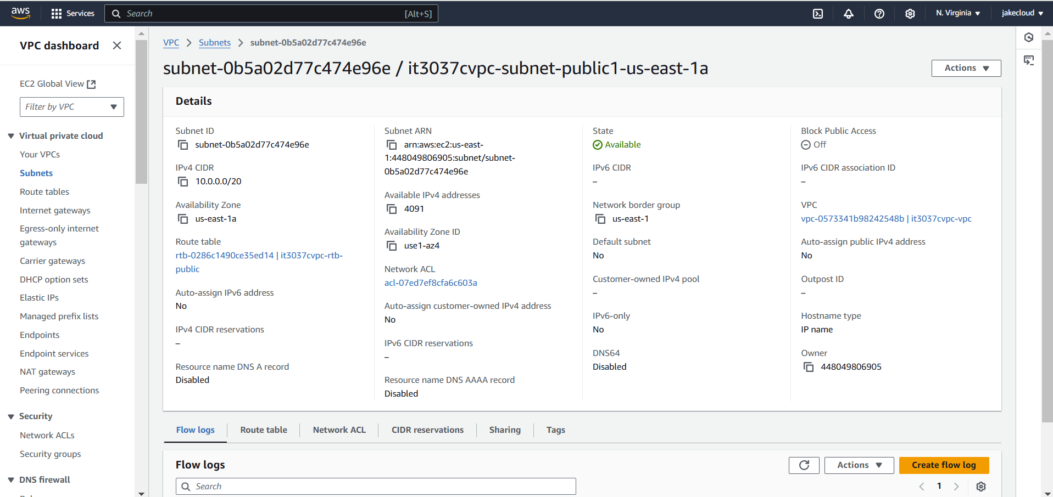

What is your subnet ID? Be sure to note your subnet id for subnet-public1-us-east-1a and your VPC id in your IDs document.
Subnet-048109d99999c8dae
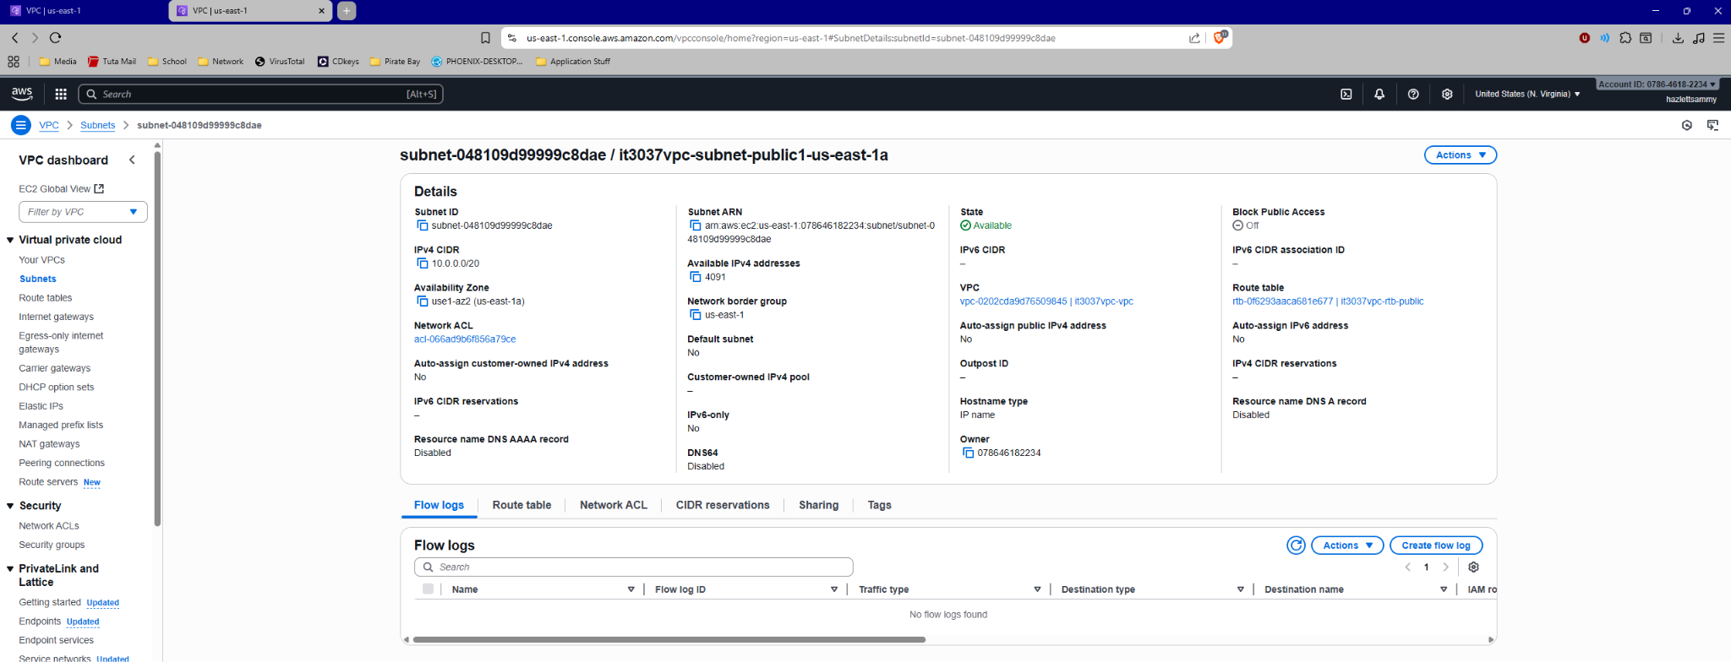
Submission instruction

After completing this work, submit this word document with your answers to Canvas. In your word document, your answers should be in blue print.

